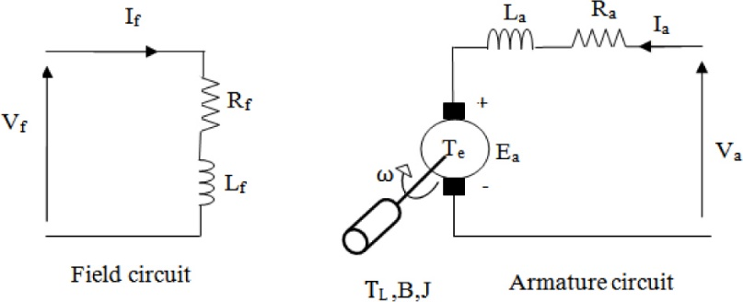

Figure 1 - Armature Controlled Separately Excited DC Motor

$$\frac{L_{a}di_{a}}{dt}=v_{a}-R_{a}i_{a}-e_{a} e_{a}=BlNr\left(\frac{dѲ_{m}}{dt}\right)=k_{m}Ѳ_{m} , k_{m}= BlNr$$

[**Electrical System Modelling**]

$$\frac{J_{m}d^{2}Ѳ}{dt^{2}}=T_{e}-f_{m}\left(\frac{dѲ_{m}}{dt}\right)-T_{L} T_{e}=k_{m}i_{a} , k_{m}= BlNr$$

[**Mechanical System Modelling**]

Te = torque developed by the machine

TL = the load torque to be overcome

ea = back emf

ia = the current in the armature

if = the field current

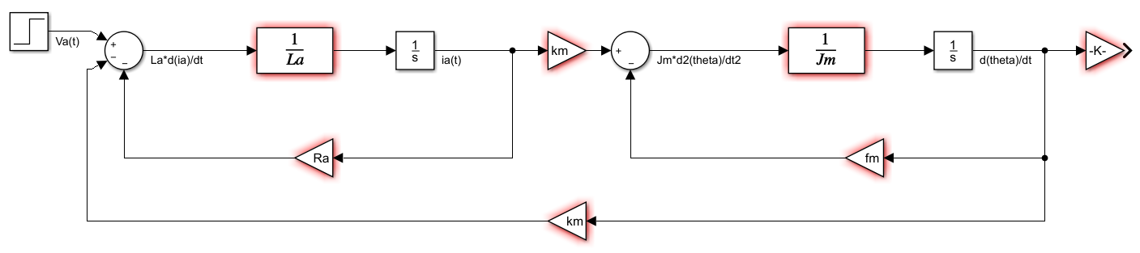

Figure 2 - Modelling of Armature Controlled Separately Excited DC Motor

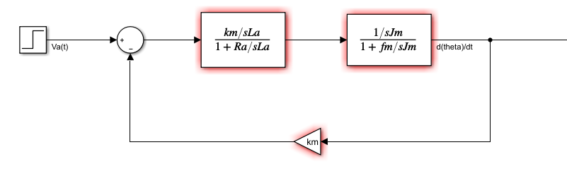

Figure 3 – Using Reducing Block Diagram Methods

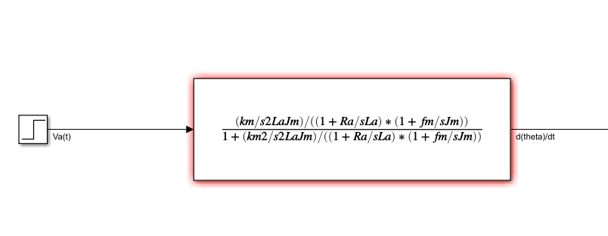

Figure 4 - Modelling of the Motor's Transfer Function

[La = 0.5H , Ra = 1Ω , km = 0.01, Jm = 0.01 , fm = 0.1 ]

$$G\left(s\right)=\frac{2}{s^{2} + 3s +20.02}$$

[**Transfer Function**]

Wn =

ξ = $\frac{3}{2w_{n}}=\frac{3}{2*4.474}=0.335$

poles = -ξwn ± jwn

s1 = -1.499 +j 4.215, s2 = -1.499 – j4.215

τ = $\frac{1}{ξw_{n}}=0.677 [Time Constant]$

ts = 4τ = 4*0.677 =2.668(sn) [**settling time**]

wd =

tp =